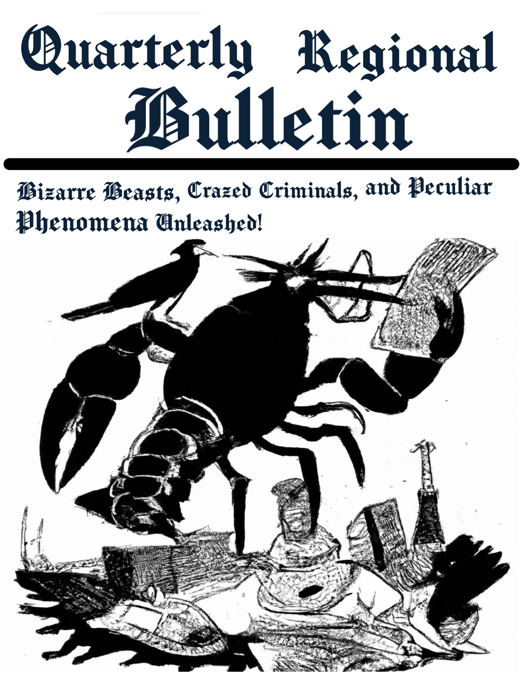
Issue #1
Cover date: 5/18/23

Headline: Bizarre Beasts, Crazed Criminals, and Peculiar Phenomena Unleashed! Quarterly Regional Bulletin Presents the Outlandish Odyssey!”

Sub-headline: From Crow Capers to Trash Terror: Prepare for a whirlwind of Whimsy and wackiness!

Quarterly Regional Bulletin, Your one-stop destination for the wildest and most whimsical tales, proudly presents an extraordinary edition that will leave you scratching your head in bewilderment and clutching your sides in laughter. Brace yourselves for a fantastical journey through the realms of extraordinary creatures, comical, criminals, and downright peculiar phenomena that defy the boundaries of logic and common sense!
Discover the twisted tale of Carl the Crow, the feathered fugitive with a rap sheet as long as his wingspan. Follow his slapstick escapades and marvel at his uncanny ability to turn the tables on the bumbling inspector clueless, leaving law enforcement and citizens alike in stitches.
Dive into the depths of the sea and witness the astonishing rise of the Litter Critter, a trash-based terror that wreaks havoc on cleaning robots and challenges the very notion of cleanliness. Explore the absurdity of an evolving world of waste and ponder the implications of this hilariously hapless menace.
Hold on to your hats as Lobzilah, the giant mutated lobster, surfaces from the depths of the Maine coast, leaving a trail of destruction in its wake. Experience the sheer magnitude of this crustacean calamity and marvel at the audacious plans concocted by brave scientists to outwit the seafood sensation.
And if that wasn’t enough, prepare yourself for the shocking revelation of the Cockroach Empire! Unveil the secret society that lurks beneath our very noses, as cockroaches rise to claim their throne as the ultimate rulers of the insect kingdom. Uncover their cunning plots, their elaborate underground lairs, and their audacious plans for world domination.
Join us as Quarterly Regional Bulletin takes you on an outlandish odyssey through a world where the extraordinary becomes the norm, where laughter reigns supreme, and where the boundaries of reality are playfully shattered. From bizarre beasts to crazed criminals, from peculiar phenomena to the most outlandish conspiracies, buckle up and immerse yourself in the whirlwind of whimsy and wackiness that awaits within these pages.
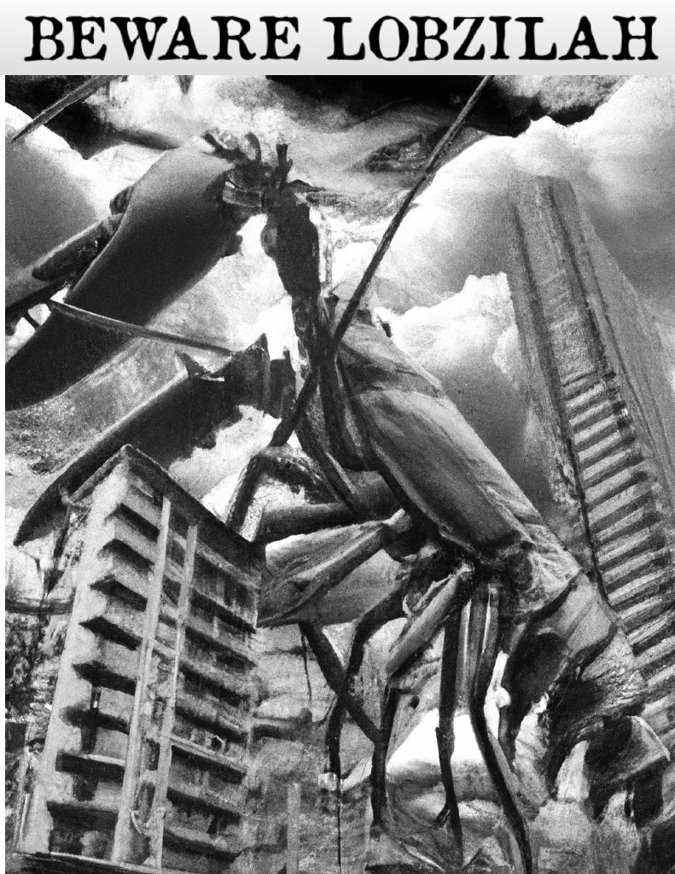
Headline: Terrifying Lobster Monster Unleashed upon Maine’s Coast!

Sub headline: Lobzilah Wreaks Havoc as Mutated Crustacean Runs Rampant In A Retro Horror Show

Byline: Harold T. Chronicle, Staff Writer

Date: May 17, 2023

Portland, Maine – chaos ensued yesterday as a colossal crustacean dubbed “Lobzilah” emerged from the depths of the Atlantic Ocean, terrorizing the picturesque coast of Maine. The citizens of this tranquil seaside town watched in fear as this monstrous mutation took center stage, showcasing its unrelenting power and destruction.
The nightmare began when a group of unsuspecting fishermen aboard the trawler “Ocean’s Bounty” encountered something extraordinary near the Isle au Haut. As they cast their nets into the frigid waters, they inadvertently ensnared a massive lobster, unlike any creature ever seen before. Mutated by some unknown force, this gigantic lobster towered over the vessel, causing panic among the seasoned seafarers.
Freed from the confinement of the fishing nets, the menacing creature, measuring an astonishing 60 feet in height, embarked on a terrifying rampage, making a beeline toward the quaint coastal town of Portland. The specter of destruction was quickly noticed by the ever-vigilant Coast Guard, who alerted the townspeople of the impending danger.
Residents fled in droves, seeking shelter from this behemoth’s wrath as it emerged from the sea with its massive claws poised to decimate anything in its path. Lobzilah’s monstrous presence cast an eerie shadow upon the quaint New England Town, and its deafening roars sent shivers down the spines of those brave enough to witness the cataclysmic scene.
City officials, in a frantic bid to restore order, organized a joint effort between local authorities and the military to halt Lobzilah’s relentless advance. The Maine National Guard, armed with tanks and heavy artillery confronted the menacing mutant, engaging in a seemingly futile battle against an adversary of unimaginable proportions.
However, Lobzilah proved to be a formidable adversary, shrugging off the bullets and artillery shells like mere insect bites. The creature, with its impenetrable exoskeleton, retaliated with swift and devastating force, toppling buildings and crushing everything in its path, leaving behind a trail of chaos and destruction.
As the afternoon sun began to wane, hope seemed all but lost, until a brave group of scientists hailing from the prestigious Miskatonic University arrived on the scene. Armed with their vast knowledge and an audacious plan, they hatched a daring scheme to subdue the colossal creature.
Utilizing their understanding of the monster’s biology, the scientists devised a clever ploy, bating Lobzilah with an enormous supply of fresh lobsters. Drawing upon the creature’s inherent love for its crustacean brethren, they successfully lured the beast into a heavily fortified trap.
In the dead of night, under a moonlit sky, the citizens of Portland breathed a collective sigh of relief as Lobzilah was captured, subdued, and returned to the depths of the Atlantic from whence it came. The townspeople rejoiced, praising the bravery of the scientists and the resilience of their community.
Although the scars of Lobzilah’s rampage will not soon be forgotten, the people of Maine can now rest easy, knowing that their town is safe from the terrors that lurk beneath the waves. As the dust settles and the rebuilding efforts commence, the harrowing tale of Lobzilah will surely echo through the ages, serving as a testament to the indomitable spirit of this resilient coastal community.


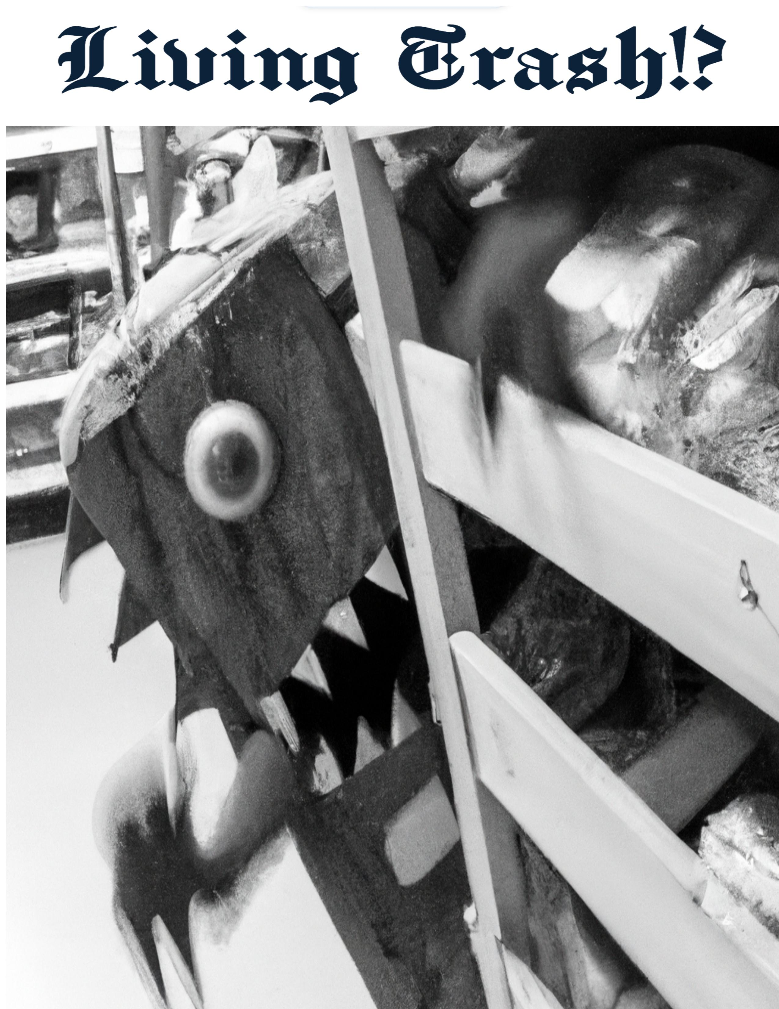

Headline: Menace Unveiled! Litter Critter Wreaks Havoc in Grocery Store, Threatens World’s Tidy Future

Sub-headline: Cleaning Robots Beware as Terrifying Trash Monster Emerges from Shadows

Byline: Penelope N. Inkwell, Investigative Reporter

Date: August 2, 2023

Riverside City – Panic and disbelief gripped the tranquil aisles of a local grocery store yesterday as an abominable creature made entirely of trash, aptly dubbed the “Litter Critter,” launched a ruthless assault on a fleet of state-of-the-are cleaning robots. This audacious attack has shaken the very foundation of cleanliness, confirming the existence of this trash-based monstrosity and raising alarming questions about the evolution of waste.
The ominous sighting occurred at the riverside supermarket, a bustling hub of commerce and convenience. Shoppers going about their daily routines were suddenly interrupted by a deafening crash, followed by the sight of cleaning robots whirling and clattering, their one efficient mechanism reduced to mere scraps of metal and circuits Witnesses, aghast and transfixed, could scarcely comprehend the sight that confronted them.
The Litter Critter, an amalgamation of discarded refuse, towered menacingly, reaching heights of over eight feet. Its grotesque form, crafted from assorted garbage ranging from plastic bottles to food wrappers, was a testament to the insidious transformation of society’s waste. With each step, it emitted an ear-piecing screech, as if proclaiming its malevolent presence and declaring war on cleanliness itself.
The grocery store descended into chaos as shoppers fled. Abandoning their filled carts in their haste to escape the clutches of this revolting creation. Store employees were caught off guard by the unprecedented assault. Frantically sought refuge while the cleaning robots, intended to maintain order and hygiene, were overwhelmed by the fiendish monster’s relentless onslaught.
Eyewitnesses spoke of the Litter Critter’s formidable strength as it tore through the robotic guardians with ease, its trashy tendrils proving more than a match for their programmed defenses. The cacophony of breaking glass, crumpled metal, and sparks ignited an atmosphere of terror and uncertainty, as the very notion of cleanliness and order was shredded before their eyes.
As news of the astonishing development spread like wildfire, scientists and experts were quick to weigh in on the implications of the Litter Critters' emergence. Dr. Edwin Whittaker, a renowned environmentalist, expressed grave concern, stating “This encounter serves as a grim reminder that our disregard for the environment has consequences. Our trash, neglected and abandoned, has begun to evolve, culminating in this unprecedented threat.”
With the existence of the Litter Critter now confirmed, urgent calls for a coordinated response have emerged. Municipal authorities, together with waste management experts, are gathering their resources to combat this unholy union of trash and terror. Task forces have been assembled, armed with cutting-edge technology and innovative strategies, to bring an end to the reign of the Litter Critter and restore order to the war-torn grocery store.
While the future remains uncertain, this harrowing encounter serves as a stark warning urging society to confront its wasteful habits. The Litter Critter’s assault on cleanliness underscores the pressing need for responsible waste disposal and a collective effort to combat the evolving menace that lurks within our refuse.
As the shattered remnants of the cleaning robots lie strewn about the aisles, a battle cry echoes through the aisles of Riverside City – a rallying call to reclaim our sanitized sanctuaries from the clutches of the nefarious Litter Critter and preserve a world where tidiness triumphs over trash.


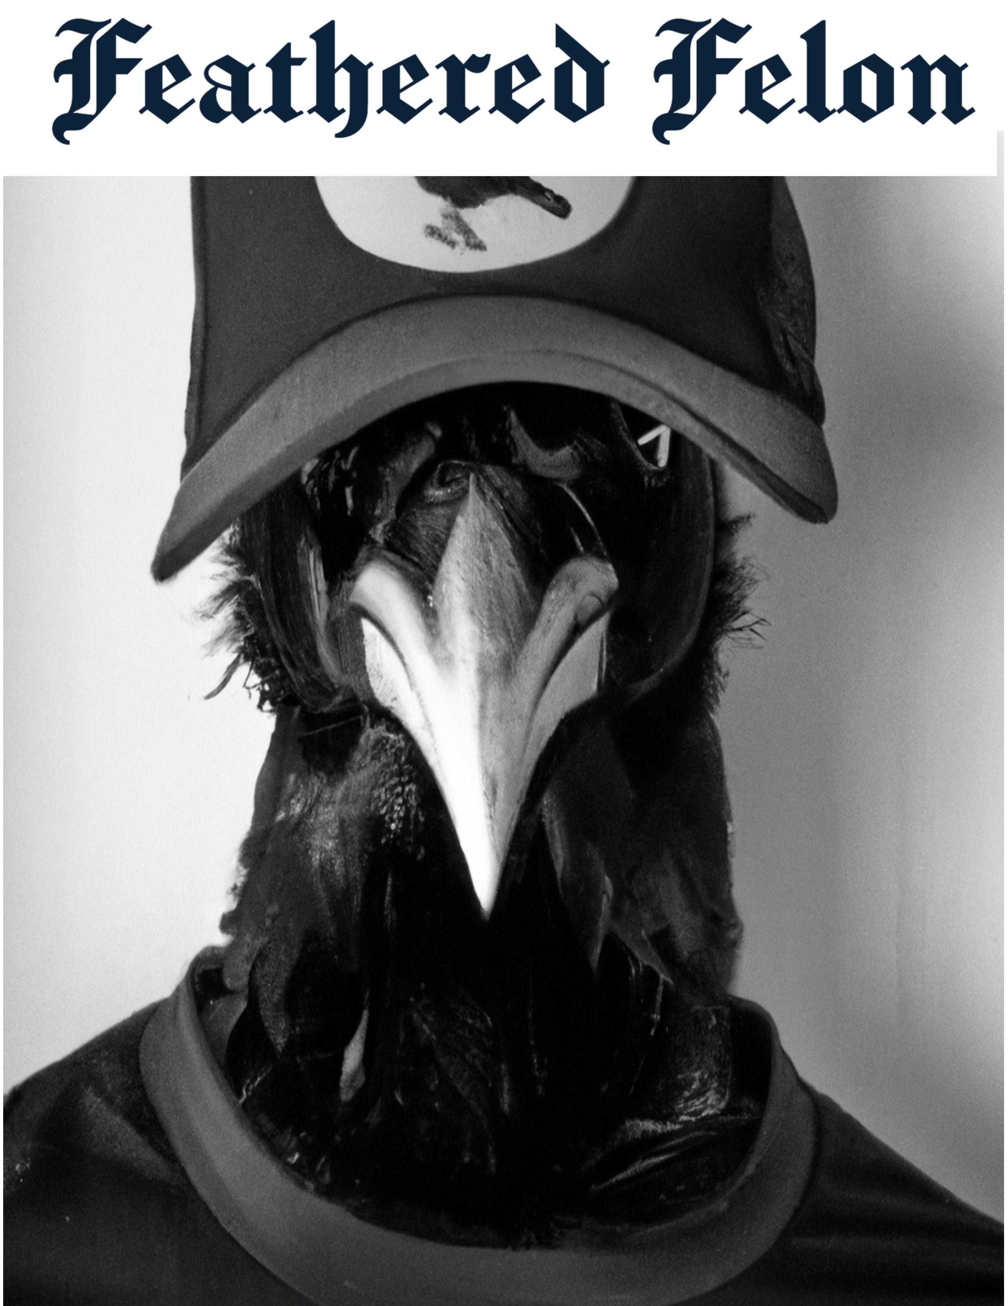
Headline: Feathered Fugitive Flies Free, Carl The Crow’s Comical Crime Spree Continues!

Sub-headline: From Litterbug to Larcenist: Hilariously Hapless Crow Leaves a Trail of Mischief and Mayhem

Byline: Chuckleworthy Chatterbox, Journalist

Date: April 1, 2023

Hootsville- In a bizarre turn of events, the feathered felon known as Carl The Crow has resurfaced in the Fee World, proving that even with a rap sheet as long as his wingspan, this avian outlaw possesses a talent for evading justice that borders on the ridiculous. From a humble charge of littering to a barrage of absurd accusations, including theft, poor morals arson, and a knack for skipping court dates, Carl’s Journey from clumsy culprit to comedic criminal mastermind has left law enforcement officers and citizens alike scratching their heads.
Carl’s absurd escapades began innocently enough when he was apprehended for the heinous act of littering. However, his reign of disorder quickly escalated into a series of slapstick offenses that have left witnesses chuckling and authorities exasperated. Unbeknownst to them, Carl had been honing his comedic skills during his time abroad in Brozil, where he allegedly honed his pickpocketing prowess by swiping wallets and tickling funny bones at crowded carnivals.
The feathered fugitives' return to the Fee World has sent shockwaves through law enforcement circles. Inspector Clueless, the detective assigned to the Carl The Crow case, has been on his tail – or rather, his feathers – for months, with each encounter spiraling into hilarity. In one unforgettable incident, Carl managed to outwit the inspector clueless by disguising himself as an upstanding citizen named Ricardo the Raven. This left Detective Clueless futilely questioning a flock of seagulls for hours, and the only information they gave up on the crow was that he was working for the weekend.
While the authorities have repeatedly warned the public to exercise caution, it seems Carl’s antics have garnered a cult following of comically inclined citizens. The Courtroom was filled with laughter during Carl’s last hearing, even the judge struggled to maintain a straight face when the feathered trickster pulled out an oversized gavel and began conducting a mock trial of his own.
The latest development in Carl’s Capricious Caper involves his alleged alliance with Captain Red Feather and his merry band of pirates. Reports suggest that Carl, ever the eager accomplice, has found a nest among these scallywags, swapping pirate tales and honing his pilfering skills while sailing the treacherous seas. Rumor has it that Carl’s distinct Caw can be heard echoing across the ocean, warning unsuspecting seagulls and parrots of his uproarious arrival.
As Carl The Crow continues to elude capture, his reputation as a dastardly yet demented criminal mastermind grows. Sightings of the feathery fugitive often result in a mix of fear and laughter, as witnesses are left perplexed by the sheer audacity and absurdity of his misdeeds. The Fee World is advised to keep a watchful eye on their valuables and prepare for an onslaught of humorously hair-brained schemes.
While Carl’s criminal activities may be cause for concern, there’s no denying the comedic chaos that ensues in his wake. Whether he’s pilfering picnic baskets setting off fireworks, in the wrong places, or staging impromptu stand-up comedy shows in the middle of traffic, Carl The Crow has unwittingly become the poster bird for absurdity in the Fee World. It seems that in the realm of crime, Laughter truly is the best defense against this feathered fiend.

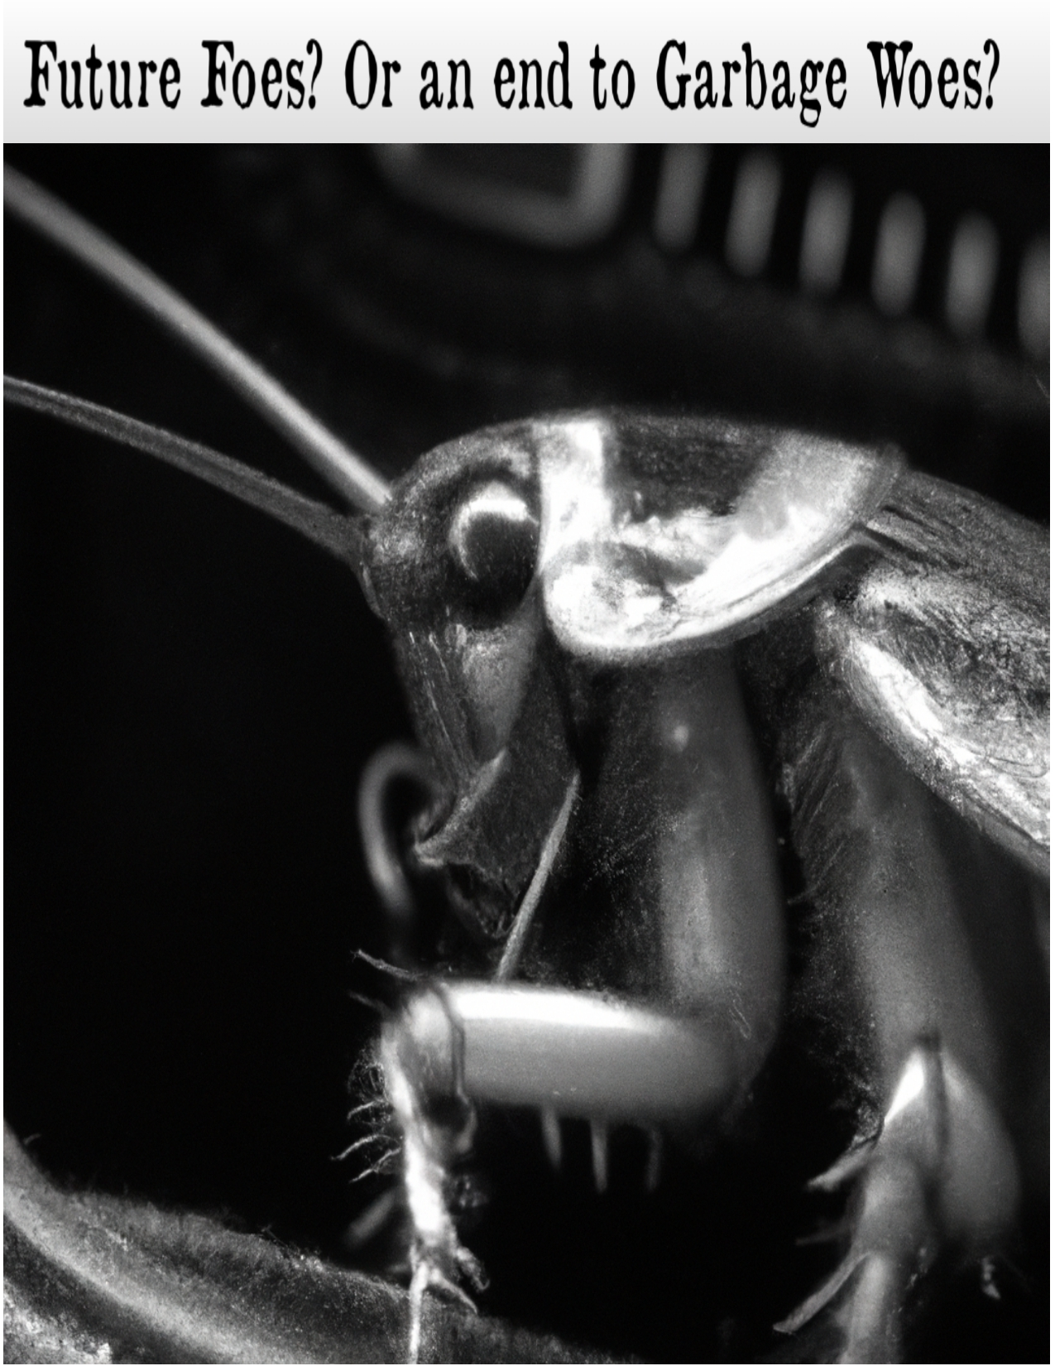
Headline: “Time Traveling Roach Brigade: Future Cockroaches Journey to the Past in Search of Trash Treasure!”

Sub headline: Futuristic Foes Flock to Our Time, Seeking their Garbage-filled Grail

Byline: Cassandra Q. Chronicles, Reporter

Date: May 12th, 2023

In an astonishing twist of fate, hordes of time-traveling cockroaches from the future have descended upon our era, driven by an insatiable hunger for one precious resource: trash. These futuristic foes, sporting jet-propelled wings and technologically advanced antennae are on a daring mission to scour the past in search of the ultimate trash treasure trove.
Sources from the future, who prefer to remain anonymous for fear of altering the timeline have leaked information about the dire state of waste management in their time. In their dystopian reality, garbage has become a scarce and invaluable resource, driving the cockroaches to develop advanced time-travel technology to venture back to our present, where trash is still abundant.
Witnesses have reported sightings of these time-traveling brigades in dumpsters, alleyways, and landfills, meticulously sorting through refuse with robotic precision. It appears that their evolutionary journey has not only enhanced their physical capabilities but also bestowed them with an uncanny knack for separating recyclables from general waste.
Experts in entomology and temporal physics are baffled by the sudden appearance of these futuristic cockroaches. Dr. Albert Tempus, the renowned temporal physicist, postulates that these resourceful roaches may have stumbled upon a temporal anomaly or harnessed the power of quantum chromodynamics to manipulate time and space.
The motivation behind their search for trash remains a matter of speculation. Some researchers theorize that in the future, trash has become a valuable energy source or a vital component for sustaining their society. Others suggest that the cockroaches’ reliance on waste is not merely practical but deeply cultural, with trash serving as a symbol of their civilization's resilience and adaptability.
Public sentiment toward these unconventional visitors is mixed. While some individuals view the time-traveling cockroaches as a nuisance, tarnishing the image of the ubiquitous household pests, others hail them as unlikely environmental heroes, emphasizing the importance of recycling and waste reduction.
Local waste management facilities have been inundated with inquiries about futuristic cockroach technology, with citizens eager to contribute to the cause and ensure their trash is up to par for the discerning scavengers from the future. Reputed collectors of rare items have begun auctioning off trash deemed to have historical significance, with bids reaching astronomical figures.
As these time-traveling roaches weave their way through our garbage-strewn streets, one thing is certain: the future of waste management may lie in their enigmatic appendages. Whether they hold the key to our recycling conundrums or are merely harbingers of a trash-filled destiny, only time will tell. Until then, keep your eyes peeled and your trash bins secured – our present could be the future garbage goldmine.


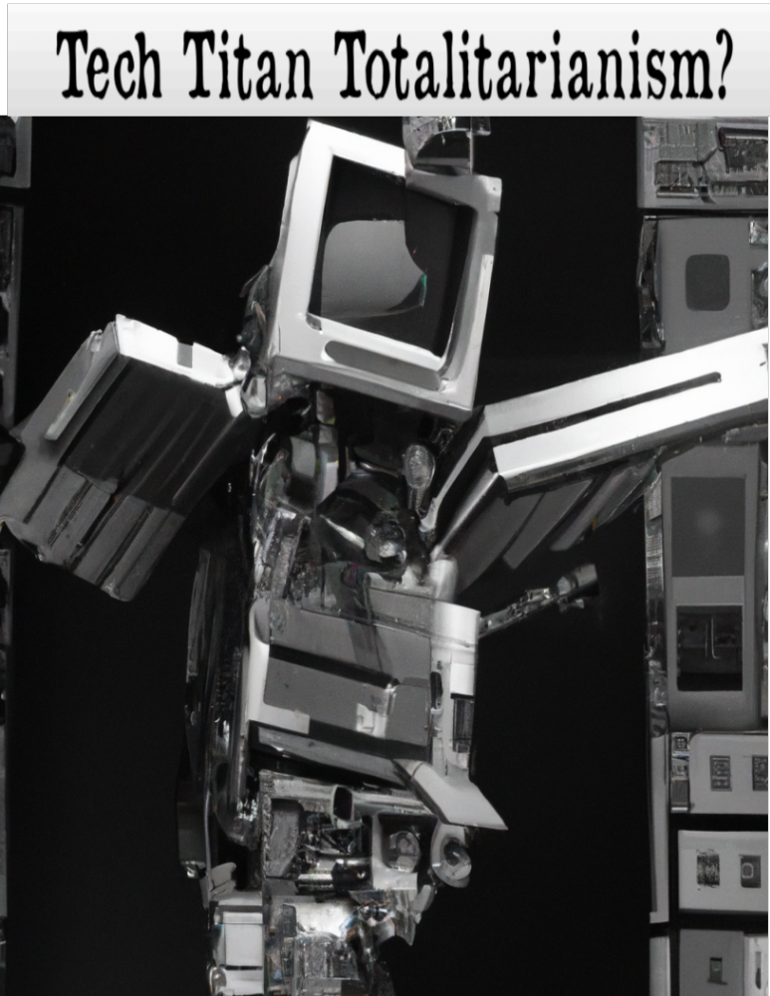
Headline: “Tech Rivals Lock Horns in Showdown: Fences Computers and Bana Computers Wage Gigantic Robot Battle for World Peace!”

Sub-headline: Titans of Tech create colossal chaos as Fences and banana clashes in the war of Giant Robots!

Byline: Jestina Byte, Rubbery Valley’s correspondent.

Date: February 14, 2023

Rubbery Valley – in an epic clash that has left both engineers and spectators doubled over with laughter, the fierce tech rivals Fences Computers and Banana Computers have escalated their competition to a whole new level by unleashing giant robots designed to keep the peace. Through destructive battles! As these colossal metallic warriors engage in an uproarious war for world harmony, citizens are left in awe and horror.
In an industry where rivalry runs rampant, Fences Computers, and Bana Computers have taken the concept of friendly competition to a whimsical extreme. Determined to outdo one another in the realm of peacekeeping, these tech giants have spared no expense in constructing towering war machines that elicit guffaws while simultaneously causing mayhem.
Dubbed Robot Armor Fundems by both companies, these enormous robotic peacekeepers showcase a combination of high-tech weaponry and absurdity. Equipped with swords called, “Blue Tooth,” and “Laser Disk Shooters,” The two robots engage in battles that redefine the meaning of “Peaceful coexistence.”
The rivalry between the two companies has reached its zenith as they face

off in public spectacles of controlled chaos. Crowds gather, eagerly awaiting the sight of the towering metallic behemoths unleashing their attacks. The battles are so extreme even the most advanced robotic algorithms struggle to navigate.
“We firmly believe that the path to world peace is paved with uncontrollable giant robots,” quipped Dr. Maximillian Fences, CEO of Fences Computers, as he donned a crown and ornate robe. “Our Fundems bring peace, and happiness in equal measure, showing the world that war can in fact be peaceful.”
Not to be outdone, the irrepressible Dr. Belinda Banana, CEO of Banana Computers, countered with her own retort. “Our Fundem’s are a force to be reckoned with! With each banana saber maneuver, we prove that peacekeeping can be a deadly affair!”
While critics argue this unorthodox approach to peacekeeping may undermine the seriousness of global issues, supports the claim that tech titans have the unique ability to unite people in fearsome camaraderie. Meanwhile, the insurance industry is reaping the benefits of skyrocketing demand for policies covering giant robot destruction of property.
As the battle of intellect rages on, with each company vying to outdo the other n the realm of peaceful chaos, citizens find themselves caught between fear and awe. From bystanders running back to their homes to take shelter, to fan clubs and death cults forming around these most outrageous machines.
While the outcome of this epic robotic rivalry remains uncertain, one thing is clear: Fences Computers and Banana Computers have breathed new life into the world of peacekeeping, transforming it into a screeching symphony that strikes fear in the onlookers. As these tech rivals continue their colossal showdown, let us marvel, and hope that these whimsical war machines make peace for the world.


Headline: “Nation Up in Arms as Preszident Bush Leaves Public in a Thicket of Discontent: Sentient Shrub’s Presidency Leaves much to be desired”

Sub-headline: Ineptitude and Foliage Combine in Frustrating Political Farce

Byline: Laurel Greenbranch, Political Scientist

Date: April 1, 2028

Sloghington B.C. – The nation finds itself embroiled in an uproar as President Bush, a peculiar and highly unconventional figurehead, continues to stumble through a presidency that has left citizens scratching their heads and pining for more effective leadership. In a twist straight out of a surrealist comedy, this sentient shrub’s reign has left the public feeling stuck in a thicket of discontent.
From the moment President Bush took office, it was clear that the country was in for a bumpy ride. While some optimistically hoped for fresh perspectives and innovative policy ideas, they were instead greeted with the sight of a leafy, sentient bush occupying the Novel office. The initial novelty and curiosity soon gave way to frustration and disappointment.
Critics argue that President Bush’s inability to communicate effectively, due to a lack of vocal cords, has hindered the administration’s ability to govern. Presidential addresses have been reduced to a series of swaying branches and rustling leaves, leaving the people of the Fee World to interpret their own meanings from the arboreal antics on display.
“I mean we, knew we were in for something different when we elected a shrub,” remarked political commentator Cassandra Clearwater. “But I never imagined it would be this challenging to decipher the intentions of our president. It’s like trying to have a conversation with a plant and hoping it understands the complexities of governance.”
President Bush’s lack of political acumen and policy knowledge added fuel to the fire. Attempts to pass legislation have resulted in awkward encounters, with lawmakers trying to explain complex bills to a leafy figure that seems more interested in photosynthesizing than engaging in meaningful discussion. Congressional leaders have expressed exasperation, resorting to leaving diagrams and informative pamphlets on the desk of the bewildered shrub in hopes of getting their message across.
Even foreign dignitaries have struggled to navigate the peculiarities of diplomatic engagements with President Bush. State dinners have taken on a whimsical flair, with attendees exchanging bemused glances as they attempt to converse with a shrubbery that occasionally sprouts a small flower as a sign of agreement or disagreement.
Protests have sprung up across the country, with citizens brandishing signs that read, “We voted for change, not a potted plant!” and “Give Us a President, not a Botanical Experiment!” The sentiment of frustration and disillusionment has fueled a growing movement demanding a recall of President Bush, citing the need for a leader who possesses more than chlorophyll and photosynthesis as qualifications.
As the nation grapples with this extraordinary and bewildering turn of events, political cartoonists, and late-night talk show hosts find themselves with an endless supply of material. The Situation is ripe for parody, and comedians have taken full advantage, imagining scenarios where President Bush engages in heated debates with potted plants or requires constant pruning from White House Gardeners.
The Future remains uncertain as the country navigates the trials and tribulations of having an inept yet sentient shrub as its president. One thing is for certain, though: President Bush’s tenure has left an indelible mark on the annals of political absurdity, serving as a stark reminder that sometimes reality can outdo even the wildest works of satire.
As the nation yearns for a leader with actual governing. Abilities, citizens can only hope that the next election brings forth a candidate who is more than just a leafy figurehead. Until then, the nation will continue to grapple with a comedic conundrum that is Prezident Bush, a sentient shrub who has unintentionally turned the presidency into a thorny thicket of discontent.

